
CASA of Arizona
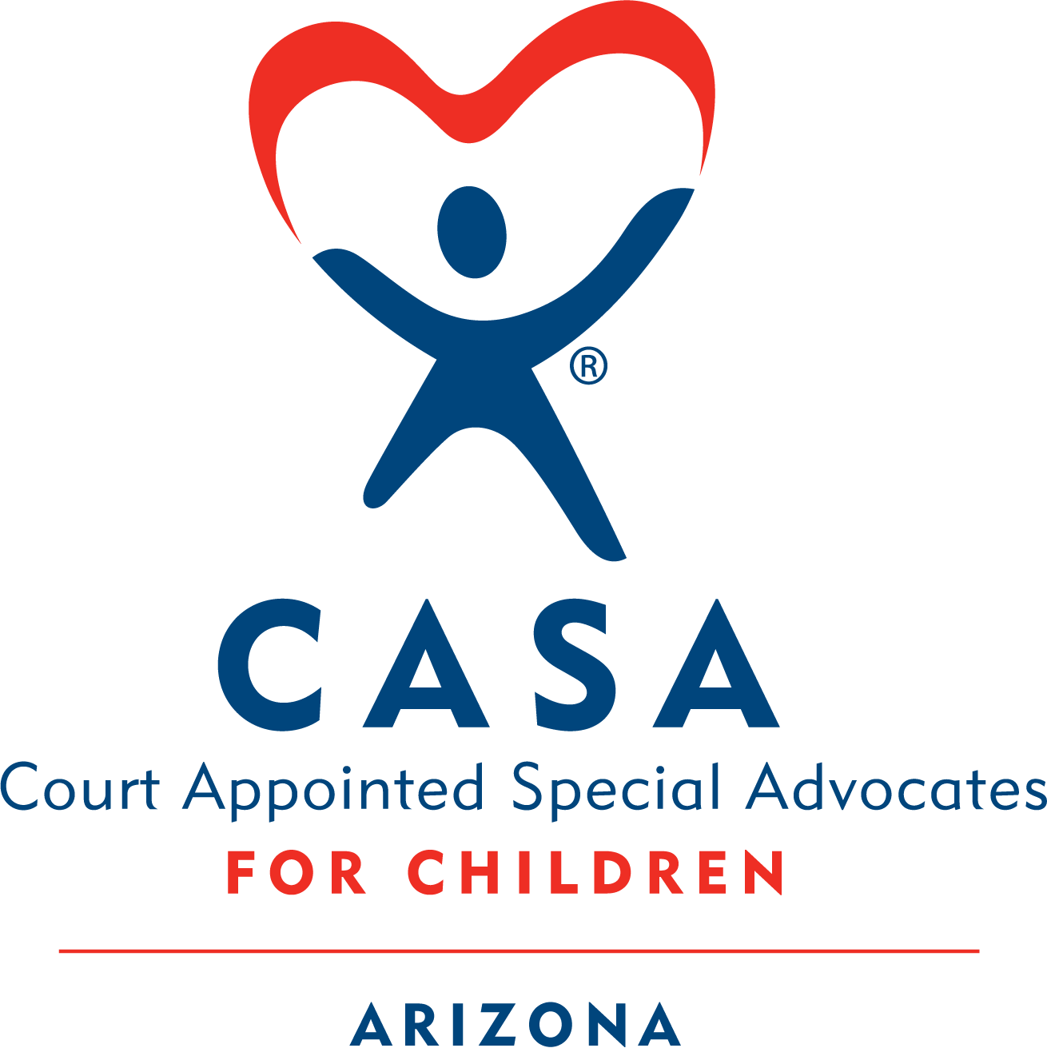
WELCOME MODULE
HOMEWORK
PACKET
Contents
❖ Activity 1.1: Introductions 2
❖ Activity 1.2: The Rosa Case 2
❖ Activity 1.3: Exploring the Impact of CASA Volunteers 3
❖ Activity 1.4: The CASA Volunteer Role in Action 3
Code of Conduct (PDF) 3
Part 1 – Four Parameters of the Volunteer Role: 4
• Information Gathering 4
• Collaboration 4
• Advocacy 4
• Monitoring 4
Part 2 – CASA Competencies Checklist (PDF) 4
❖ Activity 1.5 Child Welfare Laws 5
❖ Activity 1.6: Introduction to the Court Report 6
❖ Activity 1.7 Communication Skills 10

🚨 READ THIS BEFORE YOU START 🚨
Welcome to your first CASA Academy homework packet!
We’re thrilled that you’re exploring what it means to become a CASA volunteer—thank you for taking this step!
Before you begin:
- When you open this Word document, you may see a yellow bar at the top that says “Enable Editing.”
  - Click “Enable Editing” so you can type in the boxes and open the embedded PDFs.
- If you can’t open the PDFs or links even after enabling editing:
- Go back to the original website Welcome Module Homework. It includes all the PDFs and links as attachments.

Activity 1.1: Introductions
We want to know a little more about you. Please use the worksheet to answer some questions about yourself.
Refer to worksheet and answer the questions.

Activity 1.2: The Rosa Case

Meet the Rosa Case: Your Ongoing Training Example
Throughout this training, you’ll follow a sample case—the Rosa Case—as it unfolds. Each session will build on the last, giving you new insights and documents related to the case.
Why this matters:
- You’ll use the Rosa Case in live sessions to practice and apply what you’re learning.
- Each homework packet will include new materials about the case—so it’s important to stay up to date.
- We recommend taking notes as you go. They’ll help you participate more confidently in future activities.
Start here: Click the PDF below to read the Dependency Petition for the Rosa Case.
📂 How to open the document:
- Double-click the PDF icon labeled “Rosa Case Petition”
- If it doesn’t open, right-click the icon, choose ‘Object’ from the menu, then click ‘Open’
- If it still isn’t working, you can find a link to this document on the Welcome Module Homework website.
Refer to worksheet and answer the questions.

Activity 1.3: Exploring the Impact of CASA Volunteers

Watch This Video
Hear from two brothers as they reflect on their time in foster care—and the powerful impact their CASA volunteer had on their lives.
🎥 How to open the video:
- Click the link below labeled 20 Years Later – YouTube.
- If it doesn’t open right away, try this:
- Hold down the “Ctrl” key on your keyboard.
- While holding it, click the link with your mouse.
Still not working?
No problem! You can also find the video link in the email we sent you with this packet.
20 Years Later - YouTube

Refer to worksheet and answer the questions.

Activity 1.4: The CASA Volunteer Role in Action

Code of Judicial Administration (PDF)
CASA Volunteer Code of Conduct
Please take a moment to review portions of the Code of Judicial Administration that refer to your role as a CASA volunteer. This is a chance to self-reflect and decide if you want to assume the responsibilities of a CASA volunteer.
📂 How to open the document:
- Double-click the PDF icon labeled “CASA Code”
- If it doesn’t open, right-click the icon, choose ‘Object’ from the menu, then click ‘Open’
- If it still isn’t working, you can find a link to this document on the Welcome Module Homework website.
Part 1 – Four Parameters of the Volunteer Role:
- Information Gathering
Examples of information gathering include meeting with the child, engaging in meetings concerning the child such as Child and Family Team meetings, and accessing documents pertaining to the case such as the case plan, individualized education plan, and treatment plan (if relevant).
- Collaboration
In order to be a good information gatherer, you need to see yourself as collaborating with other members of the team such as the DCS case manager, child’s teacher, placement, therapist, family, and the youth themself.
- Advocacy
Advocacy means speaking up for the best interest of the child by making recommendations to get the child's unmet needs met. One of the biggest tasks of your advocacy is writing and submitting a court report to the judge that reflects the child’s best interest and wishes.
- Monitoring
Monitoring speaks to the continued efforts to gather information and follow up on the recommendations made. Through those efforts more strengths and needs may be identified for the family and/or the child. This may lead to the need to make more recommendations.

Part 2 – CASA Competencies Checklist (PDF)

✅ CASA Competencies Checklist: Your Self-Assessment Tool
This checklist is designed to help you reflect on the skills and knowledge needed to be an effective CASA volunteer.
Why it matters:
- You’ll revisit this checklist during your final training session.
- It’s a helpful tool to track your growth and identify areas for continued learning as you serve.
Tip: Keep this checklist handy—it’s a great resource to return to throughout your CASA journey.
What to do:
- Open the PDF icon labeled “CASA Competencies”.
- Take your time filling it out as a personal self-assessment.
- When you're done, save a copy of the completed checklist to your computer – you do not need to turn this in.
📂 How to open the document:
- Double-click the PDF icon labeled “CASA Competencies List 2025”
- If it doesn’t open, right-click the icon, choose ‘Object’ from the menu, then click ‘Open’
- If it still isn’t working, you can find a link to this document on the Welcome Module Homework website.

Refer to worksheet and answer the questions.

Activity 1.5 Child Welfare Laws
While you are not expected to be a legal expert, it is good for you to have a basic understanding of the laws that impact child welfare.
📂 How to open the document:
- Double-click the PDF icon labeled “Child Welfare Timeline and Key Federal Laws”
- If it doesn’t open, try right-clicking the icon and selecting “Open”
- If it still isn’t working, you can find a link to this document on the Welcome Module Homework website.

Activity 1.6: Introduction to the Court Report

The CASA volunteer court report is the most essential aspect of your work as a CASA volunteer. The court report is the vehicle through which you present the information you have gathered about a child’s situation and your recommendations about what services you believe will meet the child’s needs. The facts stated throughout the report are the foundation of your recommendations and should be clear, concise, and easily distinguished from opinions and assumptions.

Judges consider the information in CASA volunteer court reports as they make their decisions (they also rely on the court report from the DCS case manager and may receive other information submitted by the attorneys involved). You will submit reports for Report and Review Hearings and Permanency Planning Hearings. The CASA volunteer court report provides a way to systematically organize pertinent information and give the court a clear mental image of the child’s situation. CASA volunteer court reports are shared with all parties to a case and any other individuals who are authorized by law to receive them.
Please double click on the link below to view the Court Report template.
📂 How to open the document:
- Double-click the PDF icon labeled “Academy Sample Court Report Template”
- If it doesn’t open, right-click the icon, choose ‘Object’ from the menu, then click ‘Open’
- If it still isn’t working, you can find a link to this document on the Welcome Module Homework website.
Key Elements of a CASA Volunteer Court Report

- Brief History
- Brief Case Background/Reason for Removal. This information is often found in the Dependency Petition. This section should be brief and not include family history that is not relevant to the current dependency case and the reason(s) the child(ren) were removed.

- Assessment
- Placement information – where is the child placed? What type of placement (relative/kinship, licensed foster home, group home etc.), how long have they been in the current placement?
- Status of the Child - Describe how the child is doing in school (academically, socially & behaviorally), the physical, social, and emotional development of the child, the health of the child, whether the child is receiving services, whether and how the child’s cultural needs are being met and the child’s expressed wishes.
- Progress of the case - parental progress (or lack thereof) toward the case plan, include services provided by DCS, engagement in services, progress observed or reported.
- CASA Volunteer Activity Describe visits with the child (how many, dates, and places), contacts with others involved in the case (dates and type).
- This is a “fact-based” section and should include information gathered. It should include only information related to something reported to the CASA, observed by the CASA or read in a report or document. Do not include interpretations or opinions of the facts in this section.

- Reasonable Efforts
- Indicate current, court ordered Case Plan goal
- Remain with family, Return to family, Adoption, Guardianship, APPLA
- Provide recommendation to the Court regarding DCS efforts toward the case plan goal
- List the specific efforts made by DCS to make Reasonable Efforts toward the case plan goal
Use the following format:
The CASA recommends based on the following:
- Include items related to services DCS has provided to the family (parents, child), be specific about the services (visits are included in services and are very important for reasonable efforts)
- Consider things like placement, efforts to locate/identify family as potential placement options (including home studies for out of state relatives), also services offered to placement, resources for kinship etc.
- Consider services for older youth as well (14+) regarding transition services as well as information and assistance to pursue financial aid, post‐secondary education and/or training
- Are there other barriers present for the family? Maybe DCS has provided unique services (e.g. housing subsidy, vocational rehabilitation, SSI, citizenship issues, ALTCS)
That the Court find that Reasonable Efforts have been made by the Department.

- Opinions and Concerns
- Current or continuing challenges in the case or barriers to progress toward permanency
- Family strengths – include skills or previous success in overcoming challenges and any resources within the extended family to provide connection, respite, or additional help. Identify community resources that might provide additional support or services.
- Concerns regarding participation in and progress of provided services
- Concerns regarding services needed, any unmet needs identified including current placement’s ability to meet the child’s needs
- Concerns regarding visitation or lack of visitation
- Concerns should be related to information provided in the Assessment section

- Recommendations
- Provide a list of recommendations to meet the child’s and family’s needs that are specific and are based on the concerns and unmet needs identified and previously documented in the Concerns section which are based on the information gathered and documented in the Assessment section.
- Recommendations should include, but not be limited to, placement, services, and the permanency/case plan goal.
- Recommendations can be for services or supports for the child(ren), the parents, the placement etc.
- Recommendations should not set the parents up for failure, they should be services that promote reunification and help progress the case forward, not additional tasks that may overwhelm the parents

- Resources & Records Reviewed
- List any documents reviewed or parties spoken to in gathering information for the court report.

Refer to worksheet and answer the questions.

Activity 1.7 Communication Skills

Good Communication skills will be important to your role as a CASA Volunteer. You will need to communicate with children, parents, and many professionals involved with the case. There may be times where you are in meetings where emotions may be running high. In those times it is especially important to remain calm, practice active listening, and use good communication skills.

Active Listening
As a CASA volunteer it is important to use active listening skills for effective communication. Please read the following examples of active listening techniques:

- Clarifying statements: Help to clear up any confusing parts of the speaker’s message; are usually phrased in question form.
Examples:
- “So you aren’t sure what to do this weekend?”
- “Are you saying that you can’t find your journal?”
- “You had a good day today, is that right?”
- Paraphrasing statements: Use the listener’s words to restate the main ideas of the message.
Examples:
- “Your plans for the weekend have changed.”
- “Your journal is missing and you don’t know where it is.”
- “You were really busy today.”
- Reflecting statements: Help focus the speaker on the feelings behind the content of the message.
Examples:
- “You’re feeling confused about the change in your weekend
plans.”
- “You’re worried about your missing journal.”
- “A busy and fun day sure makes you feel happy.”
- Summarizing statements: Tie together multiple ideas expressed by the speaker to help focus the speaker’s thoughts.
Examples:
- “You were looking forward to the weekend, but your plans fell through and now you need to figure out what to do instead.”
- “It sounds like you don’t know where your journal is, and you’re concerned about someone finding and reading it.”
- “So it seems that keeping busy and doing fun things helps you have a good day.”
- Attending Behaviors: Communicate that the listener is paying attention.
- Use encouraging statements “uh huh”, “go on”, “I’m listening”
- Posture toward the speaker, maintain eye contact, nod head
- Avoid distractions
Asking Questions
Open-ended questions invite others to engage in a dialogue with you. In your work as a CASA volunteer, using open-ended questions allows children and adults to give more thoughtful answers since these questions cannot be answered with a simple yes, no or one-word answer. Sometimes open-ended questions are phrased as a statement that requires a response (for example, “Tell me about…” or “Describe for me…”).
Examples:
- Tell me your understanding of my role as a CASA volunteer?
- Tell me some things you like to do in your free time?
- What is your bedtime routine with your child like?

Closed-ended questions are useful when you are trying to obtain factual information. They can be answered with a simple yes or no, or with a single word or short phrase.
Examples:
- What grade are you in?
- Have you completed your psychological evaluation?

Clarifying questions are used to gather additional details or clear up any confusion.
Example:
- To clarify, what are the case plan tasks that are the current priority?

Leading questions are never appropriate in any CASA volunteer role.
Example:
- Your favorite weekends are spent with your dad, right?
**Do not ask leading questions. A leading question is one that suggests a desired answer.
Refer to worksheet and answer the questions.

